**FIRST UTILITY DISTRICT OF KNOX COUNTY and SOUTH BLOUNT COUNTY UTILITY DISTRICT HONORED**

**FOR DRINKING WATER PERFORMANCE**

The Tennessee Department of Environment and Conservation (TDEC) has honored the First Utility District of Knox County and South Blount County Utility District for their performance in meeting drinking water goals in a U.S. Environmental Protection Agency (EPA) program.

TDEC recently awarded First UD with a certificate recognizing success in meeting program goals for managing disinfection byproducts and South Blount with a certificate recognizing success in meeting microbial optimization goals. These recognitions stem from participation in the EPA’s Area-Wide Optimization Program (AWOP), an initiative administered in Tennessee by TDEC’s Division of Water Resources.

AWOP is a voluntary program whose primary goal is to maximize public health protection without major capital expenditure, through optimization of existing water treatment and distribution facilities. AWOP provides technical assistance and resources to systems that have water quality issues or simply want to enhance water quality. TDEC became a member of the program in 2019, joining five other states in the Southeast in EPA’s Region IV. Utilities with interest in participating in the program are encouraged to contact local TDEC staff. Additional information, resources and optimization tools can be accessed on TDEC’s AWOP web site. <https://www.tn.gov/environment/program-areas/wr-water-resources/tn-plant-optimization-programs/tn-area-wide-optimization-program--awop-.html>.

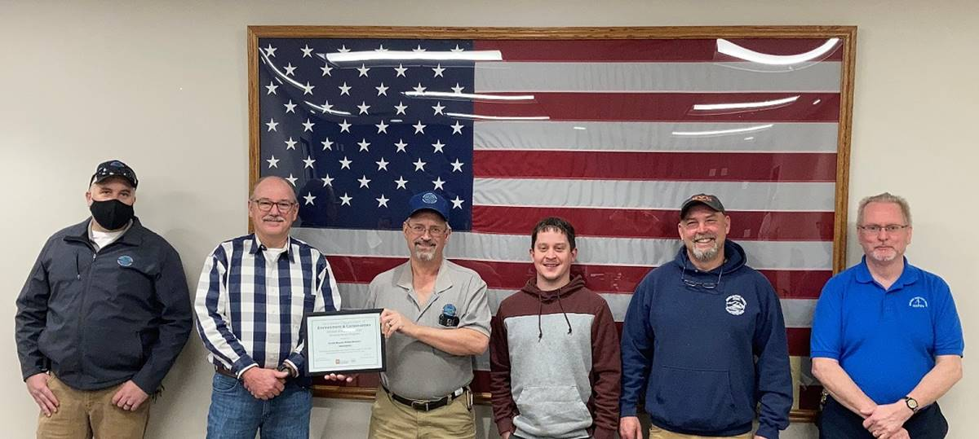

From the South Blount County Utility District are, left to right: Chris Payne, operator; A.L. Scott, general manager; Danny Pardue, chief water treatment plant operator; Brent

Stafford, operator; Eugene Durant, plant manager; and Joe Davis, operator.  Not pictured but part of the treatment plant crew are Shannon Boring, David Borum, and Jamie

Lawson, all operators.

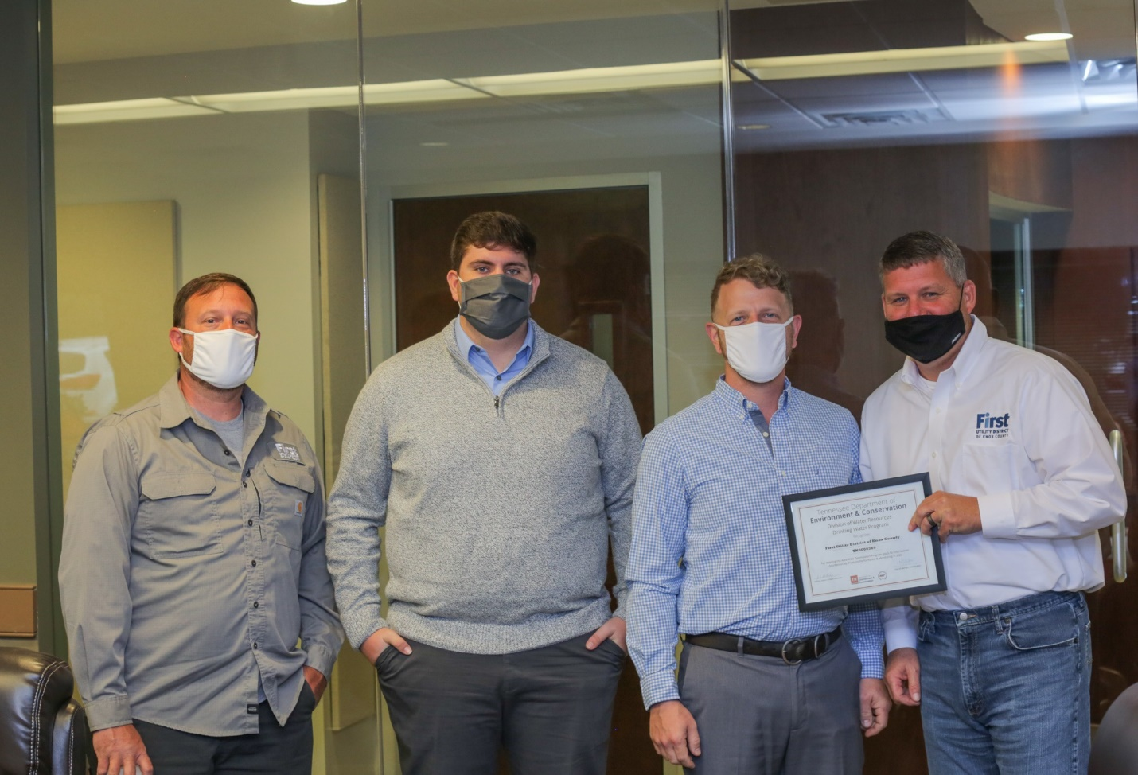

Officials of the First Utility District of Knox County are honored for their performance in the EPA’s Area-Wide Optimization Program. From left are Jimmy Miller, Jordan Durham, Travis Nicely, and Craig Mayes, environmental compliance officer.