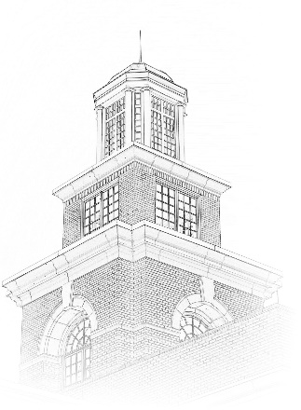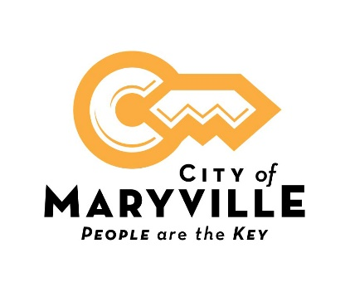

Position Title: Utility Plant Mechanic 1
Position Type: Full-time; Exempt
What we offer: The starting payrate is $17.30 per hour DOE. Comprehensive benefit package includes health, dental and vision insurance, life insurance, retirement pension with Tennessee Consolidated Retirement System, Section 457 retirement plan, Roth IRA, and 24- hour access to onsite fully equipped fitness center.
Deadline to apply: August 13, 2021
About This Opportunity:
Utility Plant Mechanics repair and maintain machinery and equipment in the City of Maryville Water Filtration Plant, Wastewater Treatment Plant, and stations throughout the system. Utility Plant Mechanics work four (4) ten- hour shifts and rotate on-call status on weekends.
Essential Functions:
- Performs repairs on pump motors and related equipment used for water or wastewater treatment lift stations, wells, storage tanks, etc.
- Uses hand, bench and machine tools in the repair and maintenance of pumps, valves and other plant machinery.
- Checks and performs maintenance and repairs on pump stations.
- Adjusts, replaces and repairs bearings, shafts, sleeves and other parts.
- Makes periodic inspections of equipment to ensure that equipment is functioning properly.
- Monitors operation of the Supervisory Control and Data Acquisition System; repairs and/or replaces electrical services and related components.
- Performs various carpentry tasks in connection with maintenance tasks.
- Performs manual cleaning and preventive maintenance duties as assigned; performs routine building and grounds maintenance.
- Lubricates and changes oil in equipment and motors.
- Designs and fabricates parts for various types of equipment.
- Performs various welding tasks in connection with repair activities.
Knowledge, Skills, and Abilities:
- General knowledge of the installation, repair and maintenance of the mechanical, hydraulic and electrical components of water treatment and pump station equipment. Proficient in the use and care of trade tools.
- General knowledge of the occupational hazards and necessary safety precautions of the work.
- Some knowledge in the use of standard office equipment, associated software and preparing reports.
- Ability to perform heavy manual work often under adverse conditions.
- Ability to make arithmetic computations, compute rates, ratios and percentages.
- Ability to follow oral and written directions.
- Ability to establish and maintain effective working relationships with associates and the general public.

Education and Experience
High school diploma or GED required.
Experience installing, repairing, and maintaining water treatment and pump station equipment preferred.
Physical Requirements:
This work requires the regular exertion of up to 10 pounds of force, frequent exertion of up to 25 pounds of force and occasional exertion of up to 50 pounds of force; work regularly requires standing, walking, speaking or hearing, using hands to finger, handle or feel, climbing or balancing, stooping, kneeling, crouching or crawling, reaching with hands and arms, pushing or pulling and lifting and frequent sitting, tasting or smelling and repetitive motions; work requires close vision, distance vision, ability to adjust focus, depth perception, color perception and peripheral vision; vocal communication is required for expressing or exchanging ideas by means of the spoken word and conveying detailed or important instructions to other accurately, loudly or quickly; hearing is required to perceive information at normal spoken word levels and to receive detailed information through oral communications and/or to make fine distinctions in sound; work requires preparing and analyzing written or computer data, visual inspection involving small defects and/or small parts, using measuring devices, assembly or fabrication of parts within arm’s length, operating machines, operating motor vehicles or equipment and observing general surroundings and activities; worker is regularly working near moving mechanical parts, exposure to outdoor weather conditions, exposure to extreme cold (non-weather), exposure to extreme heat (non-weather) and exposure to the risk of electrical shock, frequent exposure to wet, humid conditions (non-weather), working in high, precarious places, exposure to fumes or airborne particles, exposure to toxic or caustic chemicals, exposure to vibration and exposure to blood borne pathogens and may be required to wear specialized personal protective equipment; work is generally in a loud noise location (e.g. heavy traffic, large earth-moving equipment).
How to Apply:
A City of Maryville employment application is required for consideration. An electronic application is available on our website, www.maryvillegov.com/jobs. Paper applications are available in the front lobby of the Maryville Municipal Building, 400 W. Broadway Ave., Maryville, TN 37801. Please submit your application, resume and cover letter by email to humanresources@maryville-tn.gov , by fax to 865-273-3434 or in person in Human Resources.

City of Maryville is an equal opportunity employer, and all qualified applicants will receive consideration for employment without regard to race, color, religion, sex, national origin, disability status, protected veteran status or any other characteristic protected by law.

