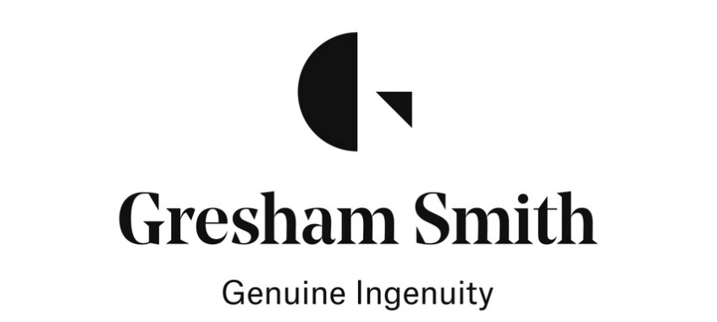

Construction Inspector – Water + Environment Market (9947)

Job Title: Utility Construction Inspector - Water + Environment Market

Location: Nashville, TN US (Primary)

Job Type: Full-time

Job Function: Construction Inspection

Education: High School/GED

Our water + environment team develops technical and strategic solutions that keep the community healthy and resilient—with a right-sized, responsive approach.

Responsibilities:
- Observe and inspect construction work and prepare daily inspection reports. Typical duties include observation of daily construction work including earthwork, erosion control, reinforced concrete, underground piping both process and plumbing, above ground process and plumbing as well as equipment installation.
- Interpret project drawings, observe construction work in progress, and check compliance with specifications, contract drawing and approved submittals/shop drawings.
- Refer deviations from plans and specifications to management.
- You may also take part in reviewing submittals, assisting with RFI's, and other related activities.
- General knowledge of construction techniques, design, and shop drawings comprehension of moderate complexity is required.
- Ability to learn on the job through observation of others and asking questions is acceptable.
- Familiarity with the use a computer and general software for reporting.

Minimum Qualifications:
- High school diploma (GED) with 10+ years of experience in construction/inspection on a variety of municipal projects or Associates Degree with 8+ years of experience.
- Experience in rehabilitation construction methods and water/wastewater facilities construction, including pump stations, sanitary sewer piping, storm water, and water main replacement a plus.
- Licenses/Registrations/Certifications are encouraged, and applicant may be required to participate in certification and training courses post-hire as required by OSHA, industry and/or client-specific requirements. Such certifications could include concrete, asphalt certifications, erosion control, environmental and hazardous materials training, etc.
- Physical demands: Frequently required to walk (including walking in rough terrain outdoors), stand, sit, use hands to operate, handle objects, tools, or equipment. Ability to talk, see and hear, and reach with hands and arms, walk, stand, or stoop. Frequently required to lift or move up to 25 lbs. and occasionally over 25 lbs. Reasonable accommodations may be made to enable individuals wanting assistance to perform these essential functions.
- Work Environment: Field – outdoors; exposed to environmental elements to include humidity, dust, noise, various temperatures; work in various high traffic areas.
- Use of personal protective equipment required and provided by firm.

Gresham Smith is committed to fostering a diverse workforce and is proud to be an Affirmative Action/Equal Opportunity Employer of Minorities/Women/Protected Veterans/Individuals with Disabilities. All qualified applicants will receive consideration for employment without regard to race, creed, color, religion, sex, age, national origin, veteran status, disability, or any other classification protected by law.

Gresham Smith will not accept unsolicited resumes from recruiters, headhunters, contract recruiters, search firms or employment agencies. An executed GRESHAM SMITH PLACEMENT SERVICES AGREEMENT (PSA) is required prior to any payment obligation for either a referral or recruiter fee. In the event a recruiter or agency submits a resume or candidate without a previously executed PSA, Gresham Smith explicitly reserves the right to recruit and hire those candidate(s) at its discretion, and without any financial obligation whatsoever to the recruiter or agency. Any such unsolicited resume or candidate contact information, including those submitted directly to Gresham Smith’s hiring managers or any other employee, shall become the property of Gresham Smith upon receipt.

