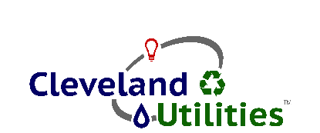
CLEVELAND UTILITIES
WATER TREATMENT PLANT OPERATOR
NIGHT SHIFT

ESSENTIAL FUNCTIONS:
- Review quality control results and trends in plant performance to evaluate operational adjustments
- Make operational adjustments based on quality control results and plant performance
- Monitor status of water distribution system and implement adjustments based upon known values and conditions
- Maintain detailed records of quality control results and operational adjustments
- Establish adequate quantities and appropriate feed rates of treatment chemicals
- Perform general plant housekeeping/cleaning
- Other miscellaneous duties as required by the chief operator or supervisor
- Proper utilization of all computers, recording devices, meters, machines, pumps, and motors
- Accurate and timely records of the plant status and operational conditions

PERSONAL REQUIREMENTS:
- A high school diploma or GED equivalency required
Associate Degree (two-year college or technical school) preferred
- Ability to use Microsoft Windows, MS Office, understand charts and graphs and interpret results required
- Knowledge of (SCADA) software a plus
- Tennessee certification as Grade III or IV Water Treatment Plant Operator preferred but not required. Must be able to obtain a minimum of a Grade III certification within 18 months of qualifying
- Hold and maintain a Tennessee Class D vehicle operator’s license
- Ability to work a 6p to 6a schedule (to include every other weekend and scheduled holidays)

PHYSICAL REQUIREMENTS:
- Ability to lift and carry up to 50 pounds of chemicals or equipment
- Ability to climb stairs and ladders, and ability to enter and exit manholes and pits
- Ability to handle high-pressure water hoses
- Ability to wear self-contained breathing apparatus for extended periods

Qualified applicants should submit an up-to-date resume by Friday, June 17, 2022:

CLEVELAND UTILITIES
P.O. BOX 2730
CLEVELAND, TN 37320-2730
Or Email to: dhitch@clevelandutilities.com

AN EQUAL OPPORTUNITY EMPLOYER

