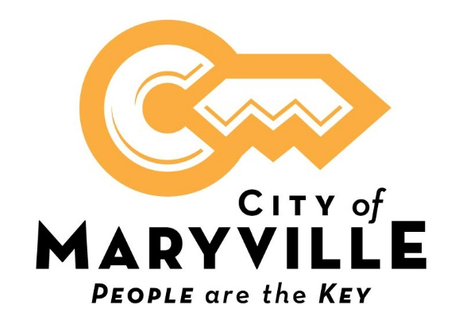
The City of Maryville is seeking a GIS Technician. This position performs intermediate technical work assisting with the maintenance of an Enterprise GIS database that supports the day-to-day mission of City of Maryville Public Utilities.
Minimum qualifications include an Associate degree with coursework in geography, geographic information systems (GIS), surveying, computer science, planning, or related field and moderate experience working with geographic information systems (GIS), or equivalent combination of education and experience.
Minimum annual salary is $44,947 DOQ. The City of Maryville offers a comprehensive benefits package including health, dental and vision insurance, life insurance, retirement pension with the Tennessee Consolidated Retirement System, Section 457 plan, Roth IRA and 24-hour access to on-site fully equipped fitness center.
Complete job description, required City of Maryville employment application, and instructions on how to apply are located at www.maryvillegov.com/jobs. Resume should accompany the application.
City of Maryville is an equal opportunity employer.

