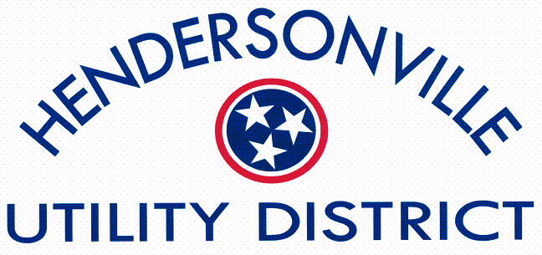

WASTEWATER/COLLECTIONS SYSTEM LABORER

Hendersonville Utility District has one (1) position available for a Collections System Laborer. A high school diploma or GED is required. This is an entry level position. Starting pay is $16.00/hour. A valid Driver’s License is required. Applicants must be at least 18 years of age. The job description and application are available in the office at 125 Indian Lake Rd., Hendersonville, TN 37075, or on our website at hendutil.net. An application must be submitted for consideration. Applications can be submitted in person or via email at hr@hendutil.net. Applicants considered for this position will be subject to a background check, and pre-employment drug screening in compliance with applicable laws and regulations regarding a Drug Free Workplace. For questions contact Human Resources at 615-590-2968.
Hendersonville Utility District is an Equal Opportunity Employer and Provider.

