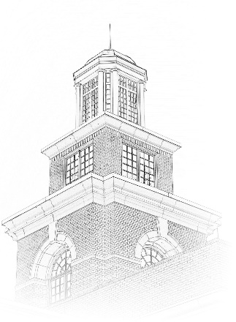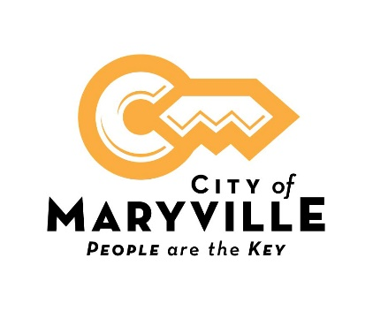

City of Maryville
Position Title: Environmental Engineer / Compliance Administrator
Department: Water and Sewer
Position Type: Full-time; Exempt
What we offer: Competitive salary based on qualifications and experience. Excellent benefit package includes health, dental and vision insurance, life insurance, retirement pension with Tennessee Consolidated Retirement System, Section 457 plan, Roth IRA, and 24- hour access to onsite fully equipped fitness center.
Closing Date: Open Until Filled.
About This Opportunity:
This is technical work developing and administering the Department’s environmental compliance programs, including industrial pretreatment, managing the spill prevention control and containment plans, and assisting plant management with the national pollutant discharge elimination system permit and risk management plan. A Bachelor’s degree with coursework in civil/environmental engineering, environmental science or related field and moderate experience in regulatory compliance is required.
How to Apply:
A City of Maryville employment application is required for consideration. An electronic application is available on our website, www.maryvillegov.com/jobs. Paper applications are available in Human Resources located on the upper level of the Maryville Municipal Building, 400 W. Broadway Ave., Maryville, TN 37801. Please submit your application, resume and cover letter by email to humanresources@maryville-tn.gov , by fax to 865-273-3434 or in person in Human Resources.

City of Maryville is an equal opportunity employer, and all qualified applicants will receive consideration for employment without regard to race, color, religion, sex, national origin, disability status, protected veteran status or any other characteristic protected by law.

