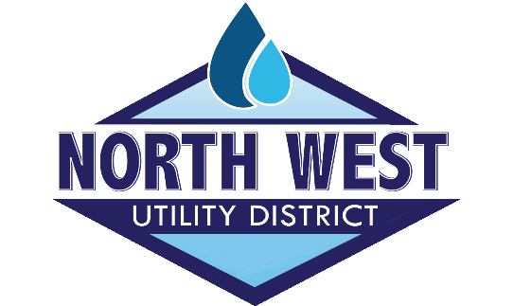

Position Title: Water Treatment Plant Operator
Reports to: Plant Manager
Job Description: The Water Treatment Plant Operator is responsible for working with management to effectively maintain and ensure that the treatment and finishing of potable water is carried out, without interruptions or problems that cannot be overcome. The WTPO is responsible for operating controls for various chemical process equipment, valves, pumps, and motors using SCADA. In addition, the WTPO performs tasks that control water flow, setting equipment controls at specified readings, gauging tank levels and recharging equipment as needed. The WTPO will communicate with the public and the maintenance department to assist customer’s questions and concerns with water outages or interruptions. If needed, after hours calls and work orders will be sent to the maintenance department following the on-call schedule. These interactions will typically occur outside of the main offices normal business hours. The WTPO works with management to ensure that assigned tasks are clearly communicated and that those tasks are carried out and completed in a timely manner. The WTPO is responsible for reporting any identified problems that cannot be corrected or resolved to the Treatment Plant Manager. The WTPO will follow communication procedures, state and local guidelines, policies and other duties as assigned.

Primary Position Requirements:
- Strong knowledge of Water Treatment processes and controls
- Review of quality control results and trends in plant performance to evaluate and troubleshoot operational adjustments
- Monitor distribution system status based on known values and trends
- Strong knowledge of occupational hazards and safety precautions
- Must have at least a Grade III Water Treatment Operator License
- Good communication skills to identify problems accurately and effectively
- Knowledge and experience with computer software and reports
- Knowledge and experience with record keeping and data entry
- Customer service and ability to adapt and respond to changing situations
- Ability to prioritize and manage time effectively

Personal Requirements:
- Preference for Tennessee Grade 3 or 4 Plant Operator’s License. Must be able to obtain a grade 4 certification within 18 months of qualifying for exam.
- Ability to use Microsoft Windows, understand charts, graphs, and basic computer functions and math calculations
- Knowledge of SCADA software a plus
- Must be flexible for working different shifts and possible holidays

Physical Requirements:
- Ability to lift and carry chemicals or equipment
- Climb stairs or ladders overhead or in pits or manholes

Education: Minimum of a High school diploma

Certifications & Licenses: Preference for TN Water Distribution license.
Work Environment: 90% indoors and 10% outdoors.
Position Type: Full time, non-exempt
Pay range: $38,000 - $55,000 Dependent upon experience and qualifications.
Apply in person at North West Utility District office, 9905 Dayton Pike, Soddy Daisy, TN 37379. You may also email apply@nwud.net for additional information or go to our website to receive an application www.nwud.net .

