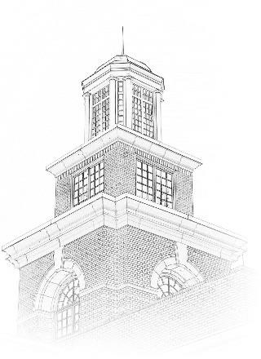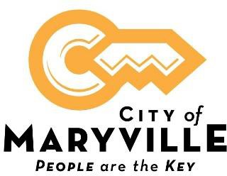

Position Title: Wastewater Plant Technicians / Operators
Location: City of Maryville Wastewater Treatment Facility
Position Type: Full-time, Non-Exempt
Starting Pay Range: $16.88 - $22.70 depending on level of TN Wastewater Operator Certification.
Work Days / Hours: Work days are Wednesday through Saturday. One position on 2nd shift (12 noon to 10:00 pm) and one position on 3rd shift (9:00 pm-7:00 am).
What we offer: Excellent benefit package includes health, dental and vision insurance, life insurance, retirement pension with Tennessee Consolidated Retirement System, Section 457 plan, Roth IRA, and 24-hour access to onsite fully equipped fitness center.
Closing Date: Open until filled.

About This Opportunity:
The Wastewater Plant Technician / Operator performs intermediate technical work in the operation and maintenance of a waste- water treatment plant, taking samples, reading gauges and charts, performing routine tests, assisting to ensure proper plant operation, and maintaining records and files.

Essential Functions:
- Maintains and operates a wastewater treatment plant; records readings from instruments; maintains records on plant operations; monitors levels and flows and makes appropriate adjustments.
- Assists with the maintenance and repair of plant equipment.
- Collects samples; performs laboratory tests in the absence of the Laboratory Technician.
- Handles chemicals and calculates correct dosage.
- Performs general custodial and grounds maintenance work.

Physical Requirements:
- This work requires the regular exertion of up to 10 lbs. of force, frequent exertion of up to 25 lbs. of force and occasional exertion of up to 100 lbs. of force.
- Work requires frequent tasting, smelling, walking, sitting, climbing, balancing, stopping, kneeling, crouching or crawling, reaching, pushing, pulling, and lifting.
- Work requires close vision, distance vision, ability to adjust focus, depth perception, color perception, night vision, and peripheral vision.
- Work requires vocal communication, hearing, and good manual dexterity.
- Requires working near moving mechanical parts. Work is generally performed in a loud noise location.
- Occasionally requires working in wet, humid conditions (non-weather), high, precarious places, exposure to fumes or airborne particles, exposure to toxic or caustic chemicals, exposure to outdoor weather conditions, exposure to the risk of electrical shock, exposure to vibration and wearing a self-contained breathing apparatus.

Knowledge, Skills, and Abilities:

Some knowledge of treatment plant principles, operating practices, maintenance requirements, and characteristics of a treatment plant.

Ability to detect flaws in the operation of equipment and to determine proper remedial measures.

Ability to understand and follow oral and written instructions.

Ability to keep records and prepare reports.

Skilled in the use and care of hand tools.

Ability to make arithmetic computations and ability to compute rates, ratios, and percentages.

Education and Experience

High School Diploma /GED
Must possess a valid driver's license to operate a motor vehicle in the State of Tennessee.
Possession of State of TN Grade III or IV Wastewater Treatment Plant Operator certification preferred.
Special Requirements
Complete Confined Space, Chlorine /Sulfur Gas and Crane Safety within 1 year of hire.

How to Apply:

A City of Maryville employment application is required for consideration. An electronic application is available on our website, www.maryvillegov.com/jobs. Paper applications are available in Human Resources located on the upper level of the Maryville Municipal Building, 400 W. Broadway Ave., Maryville, TN 37801. Please submit your application by email to humanresources@maryville-tn.gov . Applications can be submitted in-person in Hurman Resources located on the Upper Level of the Municipal Building. Please use the drop box located outside of the Administration / Human Resources door.

City of Maryville is an equal opportunity employer, and all qualified applicants will receive consideration for employment without regard to race, color, religion, sex, national origin, disability status, protected veteran status or any other characteristic protected by law.

