Title VI Certification Activity in the GMS:
Treasury’s Terms and Conditions note several statutes and regulations that prohibit discrimination to participate in this award without limitation. Of those statutes and regulations, Title VI of the Civil Rights Act of 1964 (42 U.S.C. §§ 2000d et seq.) is directly applicable to you as a grantee for participation in this grant. In the grant management system (GMS), TDEC has included a Title VI certification activity that will only need to be completed once during your ARP grant project. Additional information, along with instructions on how to complete this process, is included in the appendix of this document.
There are five (5) steps to complete the process. Some steps have additional information with screen shots (ss) to assist you with this effort. My apologies for this being so lengthy; however, I wanted to include screen shots (ss) to make the process as easy as possible.

Step 1: Log into Smart Simple GMS. The resulting screen should look like this.

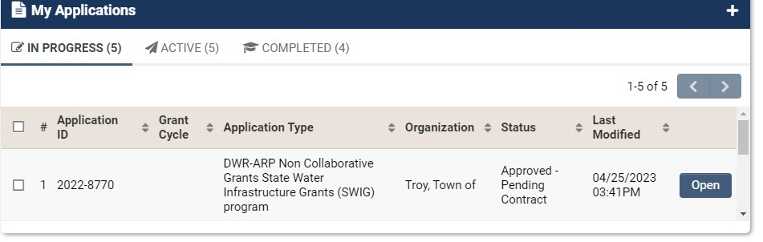

Step 2: Click “Open” to access your ARP Collaborative or Non- Collaborative Grant State Water Infrastructure Grant (SWIG).

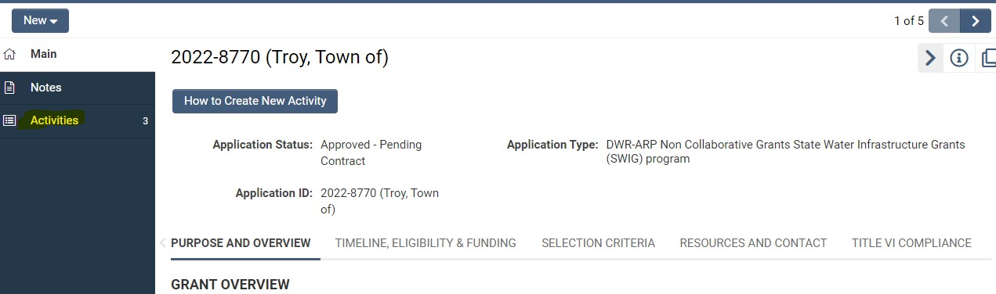
Step 3: Next, click on “Activities” located on the left side of the computer screen. The resulting screen is illustrated below. Now, click on Title VI Training Certification, illustrated below.

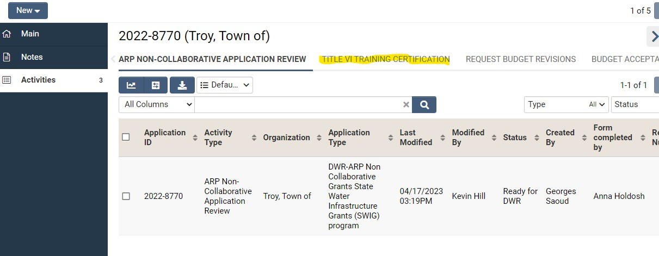

You will now need to click on the Title VI Training Certification link (see highlighted area below) to begin Step 4. This step is where you will upload some documents to the GMS. The first document is one that you will download, complete, and save to your computer. It is called the Title VI Training Certification Form.
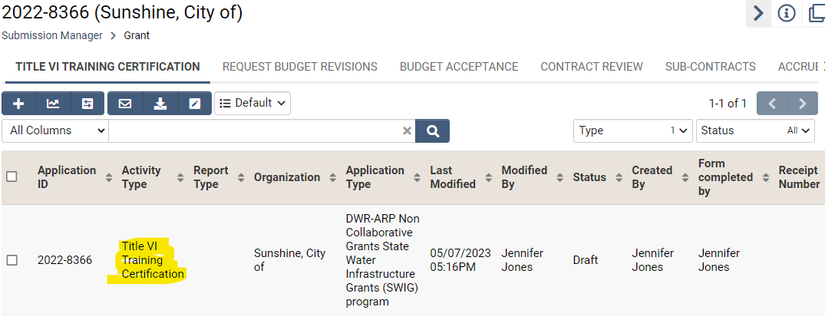

This is what your view should look like now.
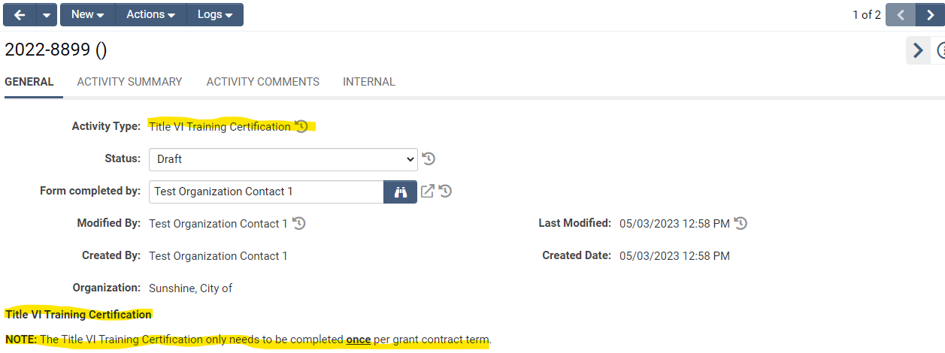
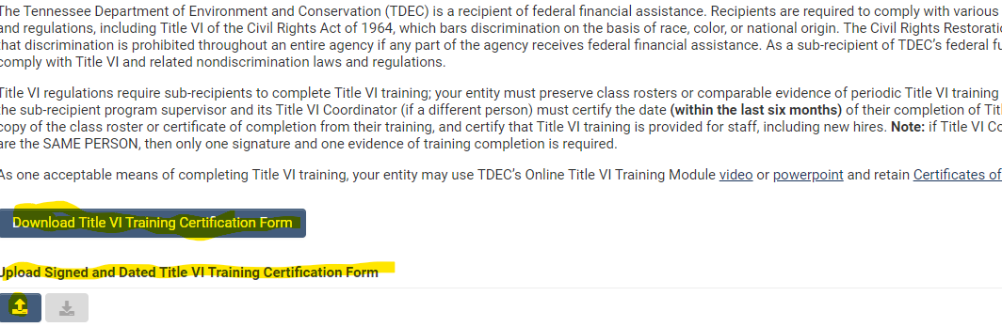
Step 4: You will now be able to download, the Title VI Certification form. Then print it, complete it, and save the document to your computer. You will need to upload the completed form by clicking on the blue box with the arrow pointing upward (see illustration below).
The ss below illustrates what your screen will look like as you upload documents to the GMS. Click on the small blue box to browse, locate, and attach your completed form. Once you upload the form, select “Save Draft”. You should be able to see that you have downloaded the document.
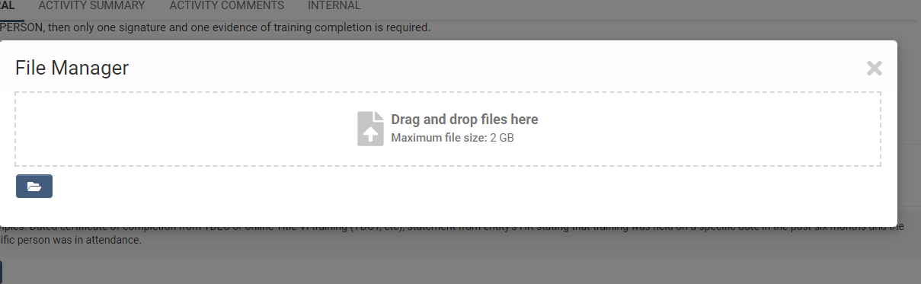
Step 5: This step illustrates how to add the Certificates of Completed Title VI training for 2 people at your agency. One of these must be for your Title VI coordinator at your agency if you have one. The other certificate can be from another employee who will be working with the ARP grant.
Just below where you added the Title VI training form, you will see another box with the arrow pointing upward. Click on the box and add the 2 required Title VI certificates of completion.
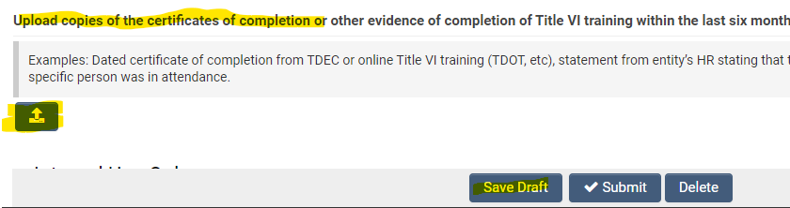
After you add the 2 documents, the screen will look like this (note that you can see the addition of your files to the GMS; however, you must click on the X at the top of the box (highlighted below). Then you need to click on the “Save Draft” button.
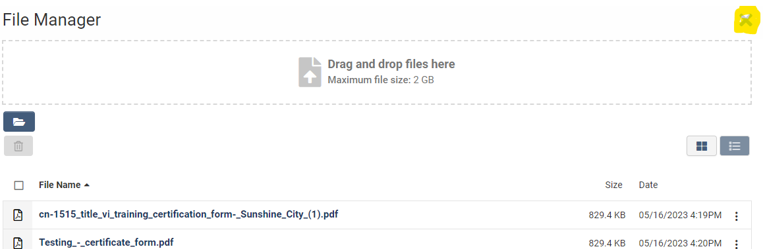
After the 2 certificates are added, you will see the following message from the GMS immediately on the screen:
SAVE is COMPLETE

Lastly, you will need to click on “SUBMIT: and you will receive another
SAVE is COMPLETE.

Call me if you have questions or need assistance. Rose Boyd at email: rose.j.boyd@tn.gov, and phone: 615 693-1565.

