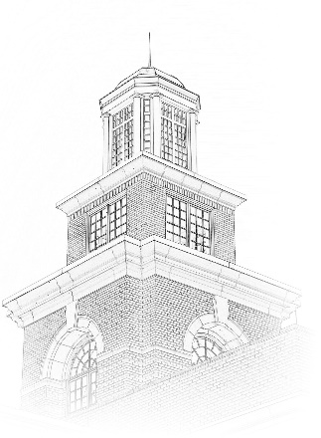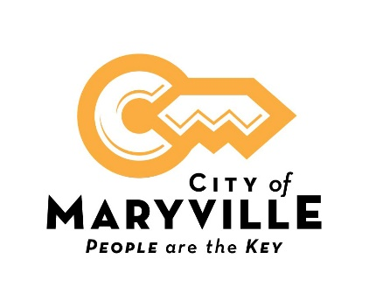

**City of Maryville**

**Position Title**: Utility Operational Technology Manager

**Position Type:** Full-time; Exempt

**Minimum Annual Salary:** $65,097

**Benefits:** Excellent benefit package includes health, dental and vision insurance, life insurance, retirement pension with Tennessee Consolidated Retirement System, Section 457 plan, Roth IRA, and 24- hour access to onsite fully equipped fitness center. Full- time employees accrue vacation and sick leave bi-weekly upon hire.

**Closing Date:** Open until Filled. Review of applications upon receipt.

**About This Opportunity:**

Manages the implementation, development, and maintenance of software, systems, and databases for the Water, Sewer, Electric, and Fiber systems. Works with stakeholders to develop and implement workflows for data collection, analysis, and reporting. Assesses, updates, and improves existing workflows using new technology, new methodology, and process redesign to improve efficiency.

**Essential Functions:**

* Manage the implementation, development, and maintenance of 4 systems; Water, Sewer, Electric, and Fiber.
* Leading new software implementation;
* Manage the integration between systems and databases (see below), including integrations involving systems and databases (Utility Billing System, etc.) managed by other departments;
* Manage the further development and improvement of software, systems, and databases to make them more efficient and effective in achieving departmental missions;
* Systems and databases include, but are not limited to: Electronic Circuit Modeling, Automated Outage Management, Interactive Voice Management, Meter Data Management, Advanced Meter Infrastructure/ Automated Meter Reading, and Sewer CCTV.
* Manage the implementation, development, and maintenance GIS for all 4 systems;
* Manage GIS Portal items (maps, apps, etc.);
* Manage and publish GIS services in ArcGIS Server Manager**;**
* Supervise, coordinate, and review GIS editing performed by GIS and non-GIS professionals;
* Supervise employees, delegate tasks, and perform employee evaluations.
* Manages and coordinates special projects;
* Implements and maintains workflows designed in collaboration with departments based on technology;
* Designs, implements, and maintains GIS, departmental, and technology workflows.
* Develops and implements computer codes and scripts to automate processes; Programming and scripting languages include, but are not limited to: Python, ESRI Arcade, and ESRI Attribute Rules.
* Train employees to use operations software and technology, use and edit GIS data, and newly implemented departmental workflows.

**Knowledge, Skills, and Abilities:**

* Comprehensive knowledge of related industry, organization and departmental policies and procedures.
* Comprehensive knowledge of related industry, organization and departmental legal guides, recommendations, best practices, ordinances, and laws.
* Thorough knowledge of understanding of engineering plans and As-Builts, GIS data models, programming documentation, and GIS analytic tools documentation.
* General knowledge of utility billing software, and workflow diagrams.
* Thorough knowledge of technical documentation reading and writing, graphs, reports, analysis, and analytics for utilities operations systems and databases.
* General knowledge of workflow documentation, creating documentation of programming code created, and GIS metadata.
* Thorough knowledge of operating GPS units and iPad/tablets.
* Comprehensive knowledge of ERSI Enterprise Geodatabase, ESRI Utility Network, ESRI ArcMap, and ESRI ArcGIS Pro.
* Thorough knowledge of Standard Office software (spreadsheets, word processing, presentations, databases, etc.), SQL Server, ArcGIS Enterprise, Python, Interactive Voice Response System, Sewer CCTV system, Automated Outage Management, and Electronic Circuit Model.
* Comprehensive knowledge of ESRI Attribute Rules.
* Thorough knowledge of CCTV inspection-driven sewer networks, electric circuit model modeling, automated outage management systems, interactive voice response systems, Water, Sewer, Electric, and Fiber utility systems, water utility GIS connectivity networks, the role and use of automation, and project management.
* Ability to coordinate people, design workflows, and lead a meeting.

**Education and Experience:**

Bachelor's degree in geography, GIS, engineering, or computer science, or related field and considerable experience in geographic information mapping systems, database management, or equivalent combination of education and experience.

Preferred training and experience include ESRI Administrative courses; Automated Outage Management training; Interactive Voice Response System experience; Electronic Circuit Model training; and Connectivity Network training.

**Special Requirements:**

Valid driver's license in the State of Tennessee.

**Physical Requirements:**

This work requires the occasional exertion of up to 25 pounds of force; work frequently sitting, speaking or hearing and using hands to finger, handle or feel and occasionally requires standing, walking, climbing or balancing, stooping, kneeling, crouching or crawling and reaching with hands and arms; work has standard vision requirements; vocal communication is required for expressing or exchanging ideas by means of the spoken word and conveying detailed or important instructions to others accurately, loudly or quickly; hearing is required to perceive information at normal spoken word levels and to receive detailed information through oral communications and/or to make fine distinctions in sound; work requires preparing and analyzing written or computer data, using of measuring devices, operating motor vehicles or equipment and observing general surroundings and activities; work occasionally requires wet, humid conditions (non-weather), exposure to outdoor weather conditions, exposure to extreme cold (non-weather) and exposure to extreme heat (non-weather); work is generally in a quiet location (e.g. library, private offices).

**How to Apply:**

A City of Maryville employment application is required for consideration. An electronic application is available on our website, Paper applications are available in Human Resources located on the upper level of the Maryville Municipal Building, 400 W. Broadway Ave., Maryville, TN 37801. Please submit your application by email to [humanresources@maryville-tn.gov](mailto:humanresources@maryville-tn.gov) , by fax to 865-273-3434 or in person in Human Resources.

***City of Maryville is an equal opportunity employer, and all qualified applicants will receive consideration for employment without regard to race, color, religion, sex, national origin, disability status, protected veteran status or any other characteristic protected by law.***