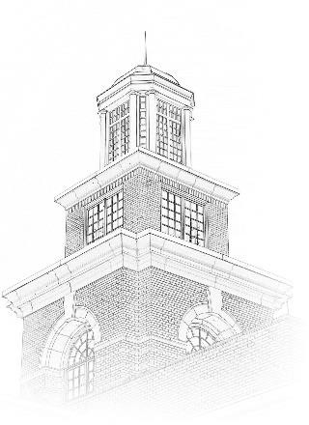 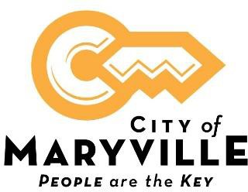

**Position Title**: Wastewater Plant Technician / Operator

**Location**: Wastewater Treatment Plant

**Position Type:** Full-time, Non-Exempt

**Minimum Pay Range: $18.18 - $24.45 +** depending on level of TN Wastewater Treatment Operator Certification.

**Work Days / Hours:** 10 Hour shift Sunday-Wednesday; 2nd shift 12:00 p.m. -10:00 p.m.

**What we offer:** Excellent benefit package includes health, dental and vision insurance, life insurance, retirement pension with Tennessee Consolidated Retirement System, Section 457 plan, Roth IRA, and 24-hour access to onsite fully equipped fitness center. Paid time off (vacation and sick leave) accrues from hire date.

**Closing Date**: Open Until Filled. Initial Review of application upon receipt.

# About This Opportunity:

The Wastewater Plant operates 24 hours a day, seven days a week. The Wastewater Plant Technician performs intermediate technical work in the operation and maintenance of a water treatment plant, taking samples, reading gauges and charts, performing routine tests, assisting to ensure proper plant operation, maintaining records and files, and related work as apparent or assigned.

# Essential Functions:

* Maintains and operates wastewater treatment plant; records readings from instruments; maintains records on plant operations; monitors flows and makes appropriate adjustments.
* Monitors Autothermal Thermophilic Aerobic Digestor and reports and operational issues to the Chief Wastewater Treatment Plant Operator.
* Collects samples; performs laboratory tests in the absence of the Laboratory Technician.
* Assists with the maintenance and repair of plant equipment.
* Handles chemicals and calculates correct dosage.
* Performs general custodial and grounds maintenance work.

# Knowledge, Skills, and Abilities:

* Some knowledge of treatment plant principles and operating practices.
* Some knowledge of the operating characteristics and maintenance requirements of a treatment plant.
* Ability to detect flaws in the operation of equipment and to determine proper remedial measures.
* Ability to understand and follow oral and written instructions.
* Ability to keep records and prepare reports.
* Skill in the use and care of hand tools.
* Ability to make arithmetic computations.
* Ability to compute rates, ratios and percentages.
* Ability to establish and maintain effective working relationships with associates.

**Physical Requirements:**

* This work requires the regular exertion of up to 10 lbs. of force, frequent exertion of up to 25 lbs. of force and occasional exertion of up to 100 lbs. of force.
* Work requires frequent tasting, smelling, walking, sitting, climbing, balancing, stopping, kneeling, crouching or crawling, reaching, pushing, pulling, and lifting.
* Work requires close vision, distance vision, ability to adjust focus, depth perception, color perception, night vision, and peripheral vision.
* Work requires vocal communication, hearing, and good manual dexterity.
* Requires working near moving mechanical parts. Work is generally performed in a loud noise location.
* Occasionally requires working in wet, humid conditions (non-weather), high, precarious places, exposure to fumes or airborne particles, exposure to toxic or caustic chemicals, exposure to outdoor weather conditions, exposure to the risk of electrical shock, exposure to vibration and wearing a self-contained breathing apparatus.
* Work requires preparing and analyzing written or computer data, visual inspection involving small defects and/or small parts, using measuring devices, operating machines, operating motor vehicles or equipment and observing general surroundings and activities.

**Education and Experience:**

### High School Diploma /GED.

Must possess a valid driver's license to operate a motor vehicle in the State of Tennessee.

Possession of State of TN Grade III or IV Wastewater Treatment Operator certification preferred.

**Special Requirements:**

Complete Confined Space and Crane Safety training within 1 year of hire.

# How to Apply:

## A City of Maryville employment application is required for consideration. An electronic application is available on our website, [www.maryvillegov.com/jobs](http://www.maryvillegov.com/jobs). Paper applications are available in Human Resources located on the upper level of the Maryville Municipal Building, 400 W. Broadway Ave., Maryville, TN 37801. Please submit your application by email to [humanresources@maryville-tn.gov](mailto:humanresources@maryville-tn.gov) . Applications can be submitted in-person in Hurman Resources located on the Upper Level of the Municipal Building. Please use the drop box located outside of the Administration / Human Resources door.

***City of Maryville is an equal opportunity employer, and all qualified applicants will receive consideration for employment without regard to race, color, religion, sex, national origin, disability status, protected veteran status or any other characteristic protected by law.***