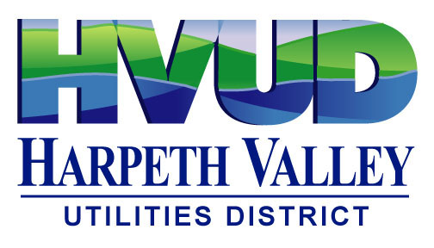

HARPETH VALLEY UTILITIES DISTRICT

GIS Specialist Posting

If interested in applying for the GIS Specialist position, please send your resume to:
HR@HVUD.com.

Harpeth Valley Utilities District is a water and wastewater utility in Nashville Davidson County, Tennessee that provides clean drinking water and waste-water service to approximately 19,000 direct customers. In total HVUD provides water to 250,000 people in Davidson and Williamson counties.

The GIS Specialist manages the development and maintenance of HVUD’s enterprise Geographic Information System (GIS) and performs all related duties. Participates in planning and performs a variety of administrative, semi-skilled and manual duties to support Engineering and other departments and functions.

Reports to: Senior Staff Engineer

Supervises Staff: N/A

Salary Range: $76,672 - $108,243

Status: Full time exempt

Experience, Education, and Skills
- Education/Experience: Equivalent to bachelor’s degree from an accredited college or university with major course work in Geographic Information Systems, Geography, Civil Engineering, Computer Science or related fields preferred or at least 5 years relevant experience in public utility operations and GIS mapping processes. Utility or Municipal Government experience preferred

- Required Skills: Minimum of 3 years of professional experience with GIS software (ArcGIS Pro, ArcMap, ArcGIS Online, ArcGIS Network and CAD drafting).

Essential Duties and Responsibilities
- Utilizes GIS technology for utility planning, asset management, and mapping.
- Collects, manages and maintains GIS data from a wide variety of sources, performing spatial analysis, designing and updating maps, and using GPS equipment for ﬁeld data collection.
- Manipulates data files by converting, importing, exporting, creating, recalling, editing, or updating data; performs detailed inspections of data for accuracy and quality during the input/edit processes and for all output formats.
- Oversees use of the ESRI ArcGIS products used by HVUD.
- Responsible for the acquisition and maintenance of GIS hardware and software.
- Assists in design, development and implementation of GIS applications, procedures, and practices, and collaborates with departments to establish workflows and standards.
- Provides GIS-related technical support and training to all departments.
- Creates and updates web mapping applications for mobile use.
- Reads, interprets and works from blueprints, plans, schematics, diagrams, technical manuals, and maps related to HVUD treatment facilities, water distribution and collection systems.
- Able to utilize GIS or CAD software for preparing visual aids and/or drafting utility construction projects.
- Understands and articulates the organization and operations of HVUD as it relates to outside agencies.
- Ensures compliance with HVUD and regulatory agencies’ policies and procedures, codes, laws, rules and regulations including safety issues.
- Serves as a resource for emerging and changing technologies as they relate to the geographic information systems field.
- Assists in selection and implementation of CMMS software compatible with GIS and other software platforms used by HVUD.
- Performs other related duties as required.
Qualifications
- Experience in field data collection using GPS technology and mobile GIS applications.
- Familiarity with geospatial data formats and GIS databases.
- Able to assist in the development of annual budgets, reports, memoranda, letters, recommendations, and other documents.
- Experience with programming procedures and activities and typical office software.
- Able to plan and organize work assignments and resources to provide timely, effective, and efficient operations.
- Possess strong analytical and problem-solving skills, with attention to detail.
- Ensure adherence to established safety rules, regulations, and guidelines.
- Work cooperatively and diplomatically with other HVUD departments and outside agencies.
Preferred Qualifications
- Experience with data governance, including standards for entry, validation, and quality control.
- Proficiency in programming/scripting languages (Python, SQL, Arcade).
- Skill in creating interactive dashboards and web applications.
- Experience integrating GIS with enterprise asset management/CMMS systems.
Working Environment:
Typical office and plant & field environment; exposure to noise, dust, grease, fumes, gases, potentially hazardous chemicals, electrical energy, & inclement weather conditions including wet &/or hot & humid conditions; work around water; work on slippery surfaces; regularly work near moving equipment & mechanical parts; and work around moderately loud noise levels; may be required to work evenings, nights, & weekends.

