Job Title | SCADA Technician
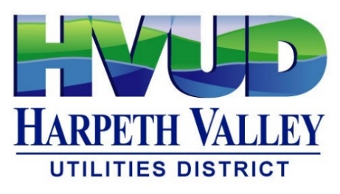
This is a hybrid of industrial automation, networking, systems administration, and utility operations. It focused on supporting water/wastewater treatment facilities through maintenance and optimization of SCADA, PLC, communication, and instrumentation.
Essential Job Duties and Responsibilities
SCADA Operations
Monitor and respond to SCADA alarms.
Maintain and optimize SCADA software and servers.
Configure alarm management and system security.
Support process optimization and operational reliability.
Industrial Controls
Program, configure, and commission PLCs and control equipment.
Troubleshoot PLC hardware and software issues.
Install and maintain instrumentation, transmitters, analyzers, and control valves.
Networking & Communications
Troubleshoot fiber-optic communication networks.
Maintain communication channels between remote sites and control systems.
Configure firewalls and secure SCADA infrastructure.
Support data communications across multiple facilities.
System Administration
Install and maintain servers, drivers, and software.
Manage software licensing and support contracts.
Maintain equipment inventories.
Follow change management procedures.
Field Work
Install, calibrate, repair, and replace field devices.
Work in water and wastewater treatment environments.
Support startup, shutdown, and maintenance activities.

Qualifications
Industrial networking and cybersecurity knowledge
An associate degree in Computer Science, Information Systems, or a related field
OR
2 years of experience installing, maintaining, or repairing SCADA systems.

Preferred Qualifications
5+ years of SCADA/PLC experience.
Water or wastewater treatment licenses.
Experience with utility operations.

Experience with systems such as:
Wonderware / AVEVA
Ignition
FactoryTalk View
GE iFIX
VTScada
Similar HMI/SCADA platforms
PLCs
Networking
Cisco Switch
Fiber optics
Ethernet/IP
Modbus
DNP3
Firewalls
Instrumentation
Flow meters
Pressure transmitters
Level transmitters
Temperature sensors
Gas analyzers
Control valves
Utility Operations

Working Conditions
- You must be comfortable working in tight or confined spaces where movement is limited.
- You may need to work nonstandard hours, including holidays, overtime, early mornings, or late evenings.
- You can be called in to work at any time, even outside your normal schedule.
- You should be willing to work in dirty, oily, or greasy environments.
- You must be able to work at heights up to 100 feet above ground, typically using appropriate safety equipment.

Physical Requirements
- You need to be able to frequently bend, stoop, stretch, crawl, kneel, squat, twist, and reach as part of the job.
- You must be able to lift and carry 26–50 pounds without assistance.
- You must also be able to lift and carry 51–100 pounds without assistance. (This is a significant physical requirement.)
- You should be able to walk about 1 mile during a workday.
- You need enough physical strength to lift, push, pull, and carry objects safely, while working within your own physical limits

